**Assignment 5.2**

**Data set:**

We have a dataset of sales of different TV sets across different locations. Records look like: Samsung|Optima|14|Madhya Pradesh|132401|14200 The fields are arranged like: Company Name|Product Name|Size in inches|State|Pin Code|Price Sales_differentTV:

<https://github.com/prateekATacadgild/DatasetsForCognizant/blob/master/sales_differentTV.txt>

**Problem Statement 1:**

Write a MapReduce program to calculate the total units sold for each Company.

**Problem statement 2:**

Write a MapReduce program to calculate the total units sold in each state for Onida company.

**Program:**

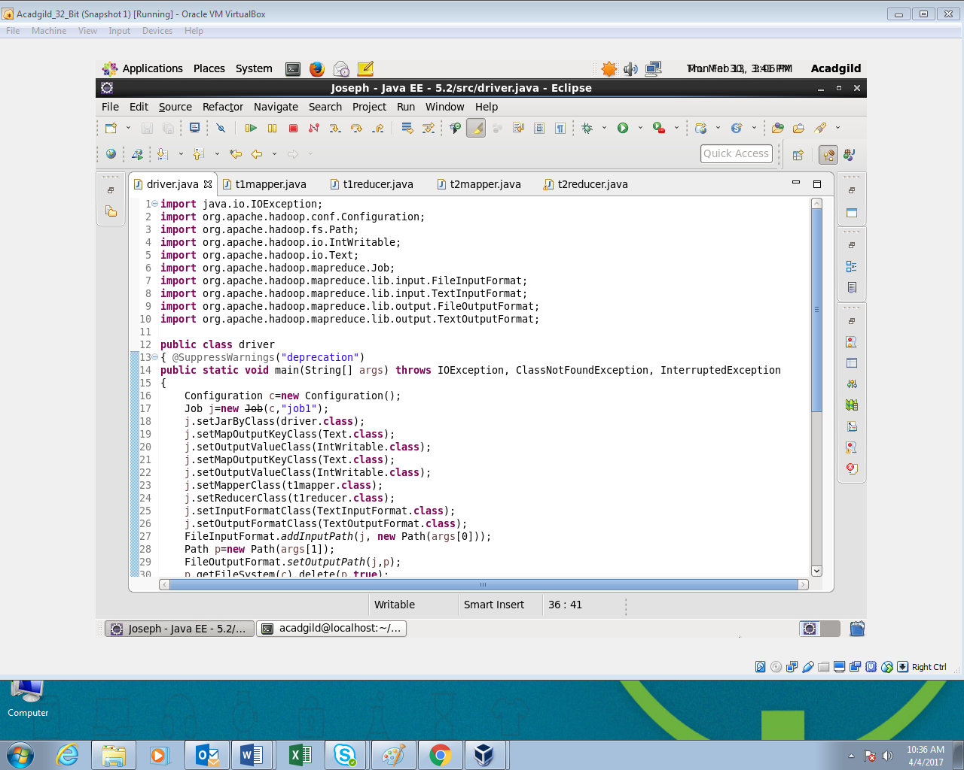

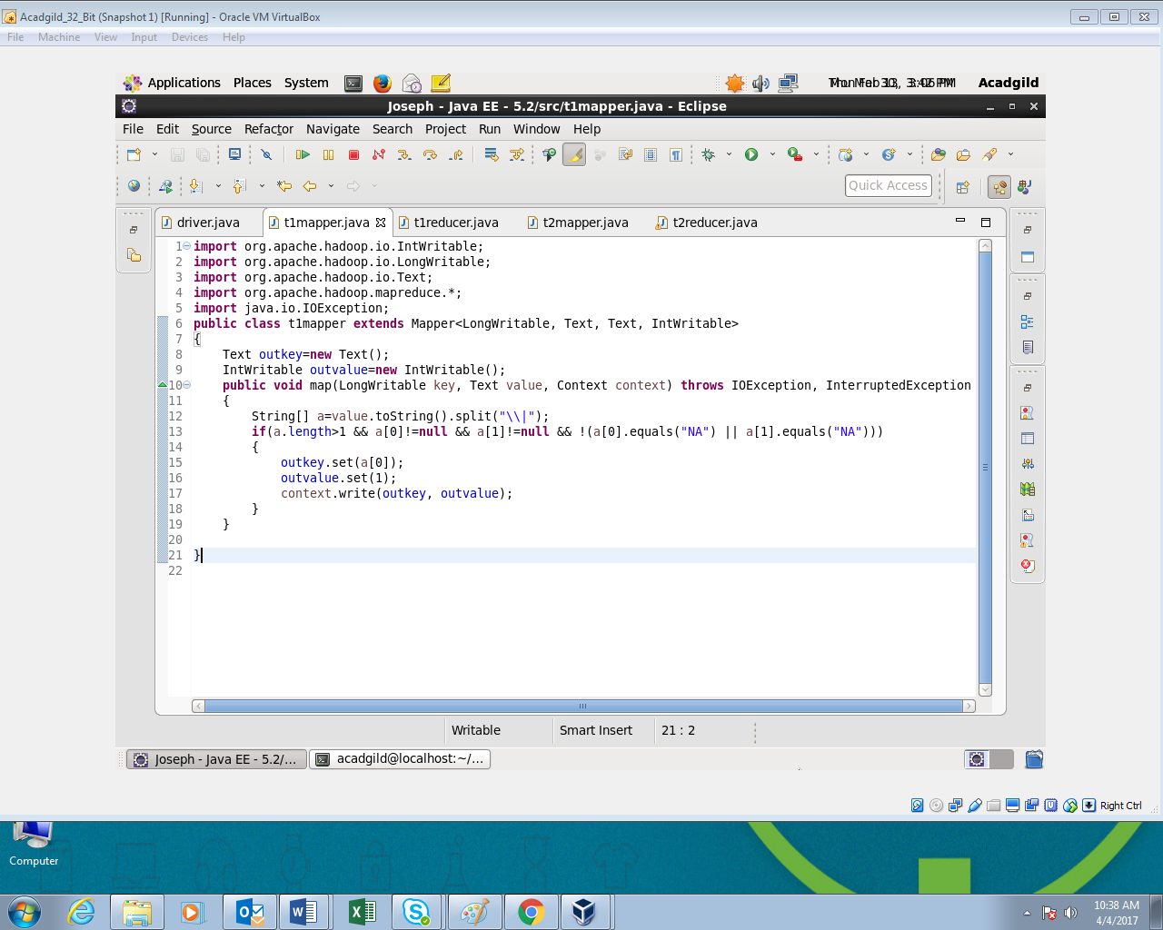

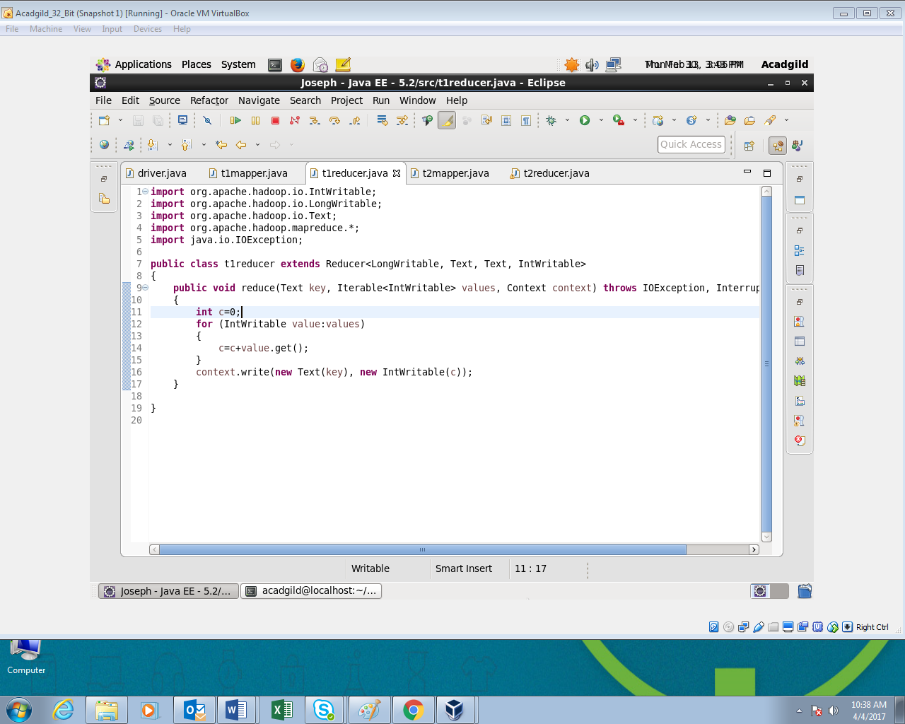

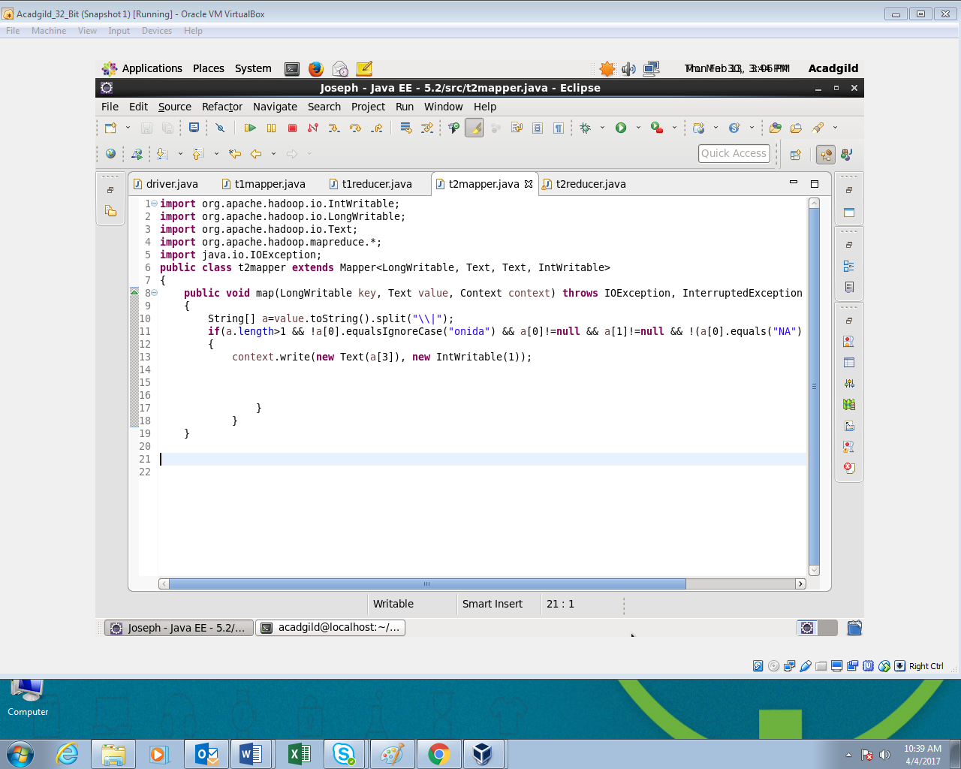

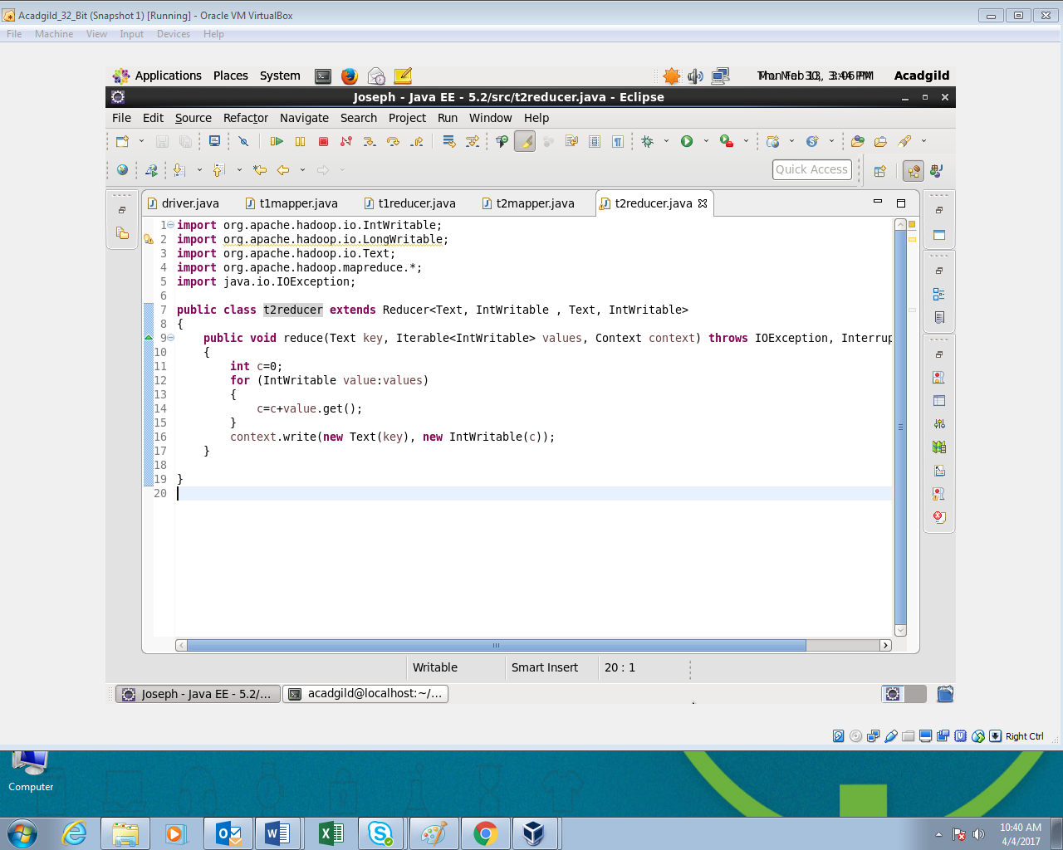

**Output:**

